**HEART FAILURE PREDICTION USING IBM AUTOAI**

**1.INTRODUCTION**

Heart failure, sometimes known as congestive heart failure, occurs when your heart muscle doesn't pump blood as well as it should. Certain conditions, such as narrowed arteries in your heart (coronary artery disease) or high blood pressure, gradually leave your heart too weak or stiff to fill and pump efficiently.

**1.1 OVERVIEW**

       Cardiovascular diseases (CVDs) are the number 1 cause of death globally, taking an estimated 17.9 million lives each year, which accounts for 31% of all deaths worldwide.Heart failure is a common event caused by CVDs There is no doubt that this alarming figure needs great attention. With the rapid development of machine learning, machine learning has been applied to many aspects of medical health for accurate predictions.

**1.2 PURPOSE**

In this project, we are buildin a model using Auto AI and build a web application where we can showcase the prediction of heart failure.. The earlier the diagnosis is obtained, the much easier we can control it. Machine learning can help people make a preliminary judgment according to their daily physical examination data and family history, and it can serve as a reference for doctors.

**2.LITERATURE SURVEY**

**2.1 EXISTING PROBLEM**

Heart failure is a condition in which the heart is no longer able to pump oxygen-rich blood to the rest of the body efficiently. This causes symptoms to occur throughout the body. Not all conditions that lead to heart failure can be reversed, but treatments can improve the signs and symptoms of heart failure and help you live longer. Lifestyle changes — such as exercising, reducing sodium in your diet, managing stress and losing weight — can improve your quality of life. Early prediction of heart failure is quite challenging task for medical practitioners due to complex interdependence on various factors as heart failures affects human organs

**2.2 PROPOSED SOLUTION**

    This project prevents the people from the avalanche by priory informing them there is a chance to the occurrence of avalanche or not.The aim of this project is to develop a system which can perform early prediction of heart failure for a patient with a higher accuracy by combining the results of different machine learning techniques and the model is been built in Auto AI.

**3.THEORITICAL ANALYSIS**

**3.1 BLOCK DIAGRAM**

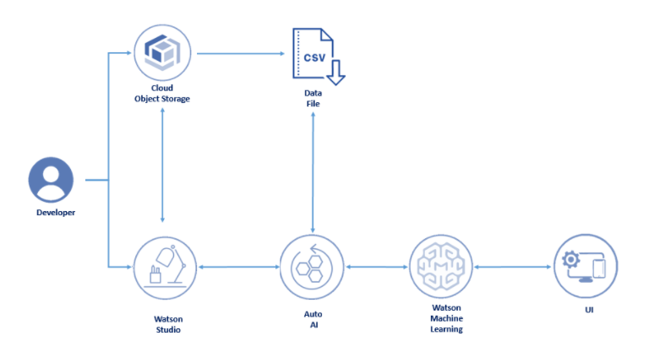

**3.2 HARDWARE/SOFTWARE SOLUTION**

**PROJECT REQUIREMENTS**

1. A Classification algorithm with maximum accuracy to be  trained and tested on the dataset.
2. The Dataset consists of 9 columns excluding the predicting column i.e. Class

**SOFTWARE REQUIREMENTS**

1. IBM Cloud
2. IBM Watson Studio
3. Node-red App

**4.EXPERIMENTAL INVESTIGATION**

**1.Choose a Project Idea:**

Predicting heart failure of a person using AutoAI.

**2 .Conduct Background Research:**

https://github.com/smartinternz02/SI-GuidedProject-3078-1623997511/blob/main/patientdataV6.csv

**3.Compose a Hypothesis:**

Based on our study and information gathered we can predict whether  a person can get heart failure or not.

**4.Design your Experiment:**

First, we need to collect the suitable dataset for our problem statement. Next, we need to run the AutoAI experiment for this problem and use the algorithm which has the highest accuracy.

**5.Draw Conclusions:**

After building our model, we can predict the class of a person(i.e.0 or 1).

**5.FLOWCHART**

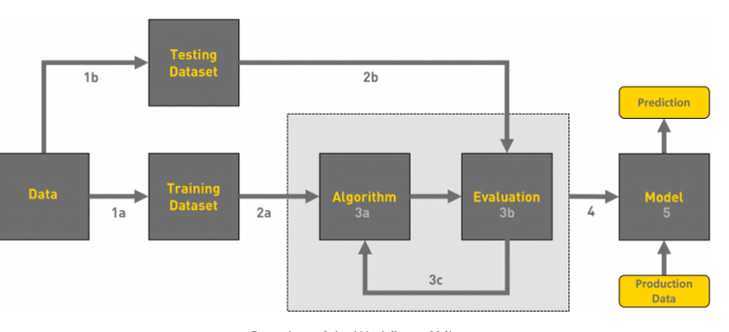

**6.RESULT**

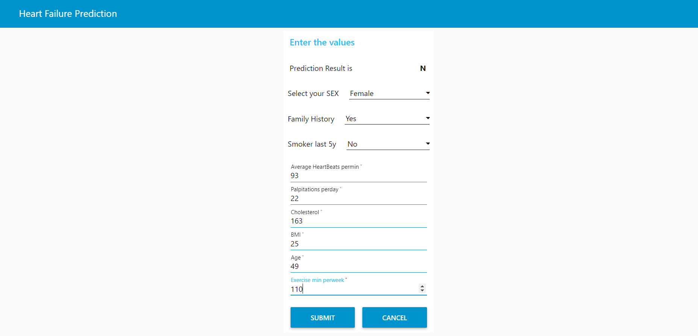

**7.ADVANTAGES AND DISADVANTAGES**

**ADVANTAGES**

1. This project prevents the people from the avalanche by priory informing them there is a chance to the occurrence of avalanche or not.
2. The earlier diagnosis is obtained, the much easier we can control it
3. Machine learning can help people make a preliminary judgment about heart failure according to their daily physical examination data and family history, and it can serve as a reference for doctors.
4. The advantage of using AutoAI is we dont need to write the code we just have to give dataset as input,it automatically builds the model using AutoAI pipeline and gives the model with highest accuracy.

**DISADVANTAGES**

**Deterministic problems:**This method is not very efficient for deterministic problems.

**Lack of good data**:it may leads to problems.

Interpretability

**8.APPLICATIONS**

1. The application is used to predict heart failures for users.
2. This system can serve as a reference for doctors.

**9.CONCLUSION**

Heart failure is a disease, which can cause many complications. How to predict exactly and diagnose this disease by using machine learning is worthy studying. The end product is an webpage created and deployed on node-red app of IBM cloud. The backend of webpage is P4 gradient Classifier built in AutoAI  with 0.883 accuracy  and deployed on watson studio using machine learning service.    The web page has input fields such as Avgheartbeatspermin, Palpitationsperday, Cholesterol, Bmi, Sex, Familyhistory, Smokerlast5yrs, Exerciseminperweek, Age and an output field named as Heartfailure which gives Y or N based on the input values.

**10.FUTURE SCOPE**

Having a heart disease is challenging and distressful. CVD patient’s condition cannot be understood only from his with medical charts. There is a need to collect and analyze both subjective and objective patient information in order to understand the occurrence of readmission of patients with CVD’s fully. This predicting information might improve the intelligent models to identify patients at high risk of readmission.

**11.BIBILOGRAPHY**

https://www.researchgate.net/publication/326733163_Prediction_of_Heart_Disease_Using_Machine_Learning_Algorithms

**12.APPENDIX**

**a)Source Code**

https://github.com/smartinternz02/SI-GuidedProject-3078-1623997511

b)Node-RED Flow Output

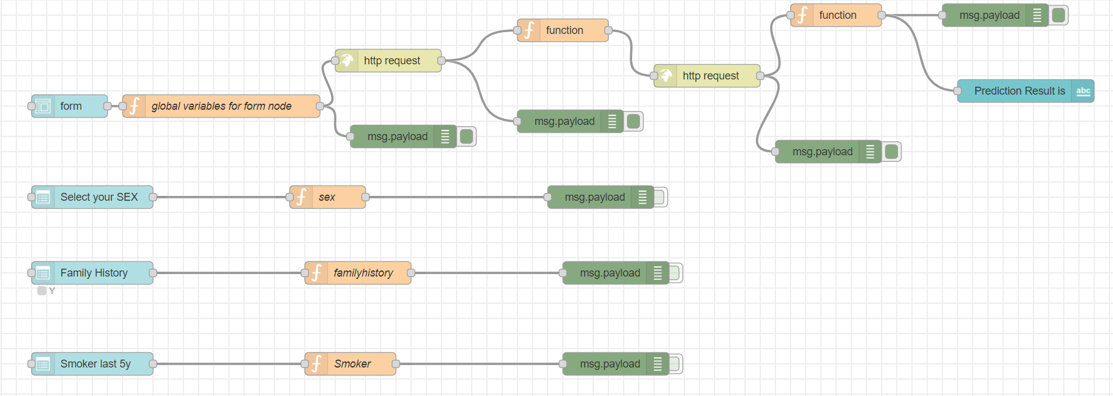

**c)UI OUTPUT SCREENSHOT**

